PSYC 439 Cognitive Psychology
Cognitive Neuromyth Meme Project
Requirements and Instructions

Purpose of the Project

The purpose of this project is to apply cognitive psychological research findings to dispel commonly held cognitive neuromyths—or false beliefs about how the brain and mind work. You’ll accomplish this by creating scientific memes that will be shared with other students in the course and (possibly—with permission) on social media.

Whether you like or dislike memes, they’re a big part of our online and social media culture. Even though the messages in memes are sometimes funny, impactful, and capture our attention, they may be totally devoid of scientific accuracy. The memes you create for this project will be used to disseminate scientifically accurate information about cognitive neuromyths. While your memes may be humorous and entertaining, they should also be scientifically accurate.

Through this project, I’m hoping you’ll appreciate how memes can be used as valid pedagogical tools. Also, given the current climate of rampant online misinformation, demonstrating the ability to clearly and concisely communicate accurate scientific findings is a useful skill. This project gives you the opportunity to do just that.

Project Requirements

Step 1: Creating Scientific Meme Drafts

● Create 2 memes based on 2 different cognitive neuromyths. Each meme should represent a different cognitive neuromyth and you can choose any 2 of the neuromyths from the list I’ve provided at the end of this handout. Your job with each meme is to highlight and correct the neuromyth.

● For each of your meme rough draft submissions, also include a written paragraph. The role of the written paragraph is to provide scientifically accurate information that dispels the neuromyth. Each meme’s written paragraph should include the following:
(a) A description of the cognitive neuromyth—what is it?
(b) An explanation of why it is a myth or misconception. In other words, why is this a myth or misconception about the mind or brain, and what does empirical research suggest instead?

● Conduct some research to assist you with busting the cognitive neuromyths you choose. In particular, what does empirical research have to say about the neuromyth? For instance, if you choose the neuromyth that “Humans only use 10% of their brains”, why is this a myth or misconception, based on empirical research findings? The goal of your research is to arm you with the information you need to clear up the myth or misconception.

● You may need to begin by relying on web sources to learn more about the cognitive neuromyths, but please don’t rely on only web sources—be sure to incorporate scholarly sources as well (i.e., journal articles, books, or other peer-reviewed sources).

● Any web sources you use should be reliable, so be sure to select web sources from reputable sites (anything on .org, .edu, or .gov are the usually the most reliable, as well as web sources that include an author and a bibliography or reference list). Please include an APA style reference list as a separate document with your meme drafts.

● To create your memes, go to a free online meme generator like MemeGenerator (https://imgflip.com/memegenerator), Quickmeme (http://www.quickmeme.com/), or Make a Meme (https://makeameme.org/). When creating your memes, be sure to select an image that is appropriate and relevant to your meme topic and include a brief and accurate meme message.

● To share your memes for peer review, post your 2 memes (along with the written paragraphs) to the meme draft discussion boards on Blackboard. Two discussion boards have been created to keep the discussion threads and peer feedback process more manageable. Create a new thread within your assigned discussion board and attach both copies of your meme drafts and written paragraphs.

Step 2: Peer Reviewing Meme Drafts

Post a reply on the meme drafts of 4 other students on your assigned discussion board. Replies should include any general comments about the meme and suggestions for improvement (if needed). My TA and I will be looking at the drafts and providing feedback as well.

Step 3: Submitting Final Copies of Memes

Based on the feedback you received, make any necessary changes to your memes before submitting the
final copies of your memes. Final copy submissions can be made using the assignment link on Blackboard. Please indicate with your submission whether you’re okay with me posting one or both of your memes on my public Twitter account.

Examples of Cognitive Neuromyth Memes and Written Paragraphs

In case it’s helpful as you prepare your meme drafts and written paragraphs, here are examples of memes and written paragraphs from prior students. These are not for use for your own project.
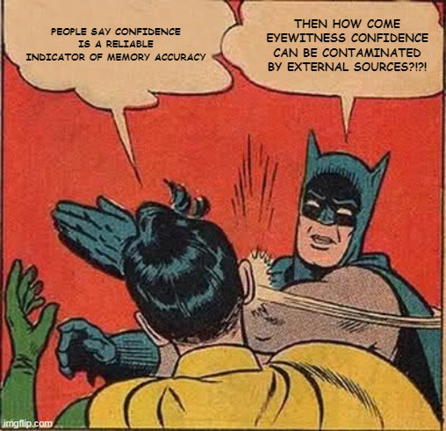
Myth: An eyewitness’s confidence is a reliable indicator of their memory accuracy.

Although eyewitness testimony is a common form of evidence in an investigation proceeding, errors in memory accuracy are often not brought to attention. An eyewitness’s confidence in their recollection of the event can be influenced by external factors. Many people believe that the more confident a person is in remembering an event, the more accurate they will be.
This particular statement is considered a myth because memory is a reconstructive process and it can be manipulated. As a result of memory manipulation, innocent people can be convicted of crimes they did not commit (Roediger et al., 2012). Certain factors like asking leading questions that may guide the eyewitness to confirm that the suspect in custody is the actual suspect of the crime. The eyewitness can easily mix up the information they were given with the information they previously had. Discussing the incident with other witnesses can also distort a person’s original memory. The other person’s memory can reshape the details of the original (Lindsay, 2004).

References
Lindsay, D. S., Hagen, L., Read, J. D., Wade, K. A., & Garry, M. (2004). True Photographs and False Memories. Psychological Science, 15(3), 149–154.
Roediger, H. L. III, Wixted, J. H., & DeSoto, K. A. (2012). The curious complexity between confidence and accuracy in reports from memory. In L. Nadel & W. P. Sinnott-Armstrong (Eds.), Memory and law (pp. 84–118). Oxford University Press.
Myth: Some people have photographic memories.
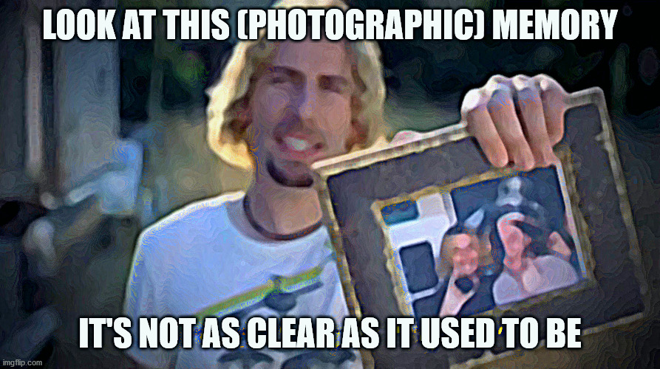
On the popular television show The Big Bang Theory, the character Sheldon Cooper claims to have a photographic memory – which he clarifies in the show is actually called an Eidetic Memory (Davies, 2020). In reality, the concept is much more complicated than it is implied in media and pop culture. First, while there is evidence that 2 to 10 percent of children aged 6-12 may have an Eidetic Memory, nearly no adults (such as Sheldon Cooper) have shown the same abilities (Ehrenfeld, 2015; Haber, 1979; Thomas, 2014). Even in children who have demonstrated the trait, something as simple as blinking after seeing the image can impact the memory and the memory is far from an actual photograph, as the children can fail to remember aspects of the image or even invent false aspects that were not present (Ehrenfeld, 2015). This discrepancy could be due to the children having an “enhanced ability or associate or organize information” (Hudmon, 2009, p. 52) rather than an actual “photographic memory” which exactly retains the image. So, while there may be a small portion of the adolescent population with an Eidetic Memory, few if any adults have one and there’s actually no such thing as a photographic memory.

References
Davies, A. (2020, July 22). Big Bang Theory plot hole: Sheldon’s eidetic memory debunked in key scene. Express.co.uk. https://www.express.co.uk/showbiz/tv-radio/1312815/Big-Bang-Theory-plot-hole-Sheldon-Cooper-eidetic-memory-mistake-CBS-video
Ehrenfeld, T. (2015, April 6). There’s No Such Thing as a Photographic Memory | Psychology Today. Www.psychologytoday.com. https://www.psychologytoday.com/us/blog/open-gently/201504/theres-no-such-thing-photographic-memory
Haber, R. N. (1979). Twenty years of haunting eidetic imagery: where’s the ghost? Behavioral and Brain Sciences, 2(4), 583–594. https://doi.org/10.1017/s0140525x00064542
Hudmon, A. (2009). Learning and memory (p. 52). Chelsea House Publishers. https://www.google.com/books/edition/Learning_and_Memory/GKdUyxrqL6kC?hl=en&gbpv=1&pg=PA52&printsec=frontcover
Thomas, N. J. T. (2014). Mental Imagery > Other Quasi-Perceptual Phenomena (Stanford Encyclopedia of Philosophy). Plato.stanford.edu. https://plato.stanford.edu/entries/mental-imagery/quasi-perceptual.html

Select any 2 of the following cognitive neuromyths for the meme project:

1) Humans only use 10% of their brains.

2) People are either right-brained or left-brained.

3) Learning can be improved if children are classified and taught according to their “learning
style” (i.e., visual, auditory, or kinesthetic learners).

4) Human memory works like a tape recorder or video camera and accurately records the
events we have experienced.

5) Brain development is finished by the time we reach puberty.

6) Eating sugar results in hyperactivity and reduced focus and attention.

7) Confidence is a reliable indicator of memory accuracy.

8) Hypnosis can be used to retrieve forgotten memories.

9) Most forgetting occurs gradually, rather than immediately after an event.

10) Listening to classical music increases children’s reasoning ability.

11) To develop expertise, all it takes is 10,000 hours of practice.

12) Individuals commonly repress their memories of traumatic experiences.

